

This is a screen shot from Ultimate Texas Hold’em

Author:
Elliot Gross
(Emg2m9@umr.edu)

Table of Contents

Introduction to the Game of Texas Hold’em 4
What is Ultimate Texas Hold’em? 5
System Requirements 5
Installation 5
Controls for Ultimate Texas Hold’em 7
Gameplay for Ultimate Texas Hold’em 10
The Rules of Texas Hold’em 18
Hand Strength 20
High Card 20
Pair 20
Two Pair 20
Three of a Kind 21
Straight 21
Flush 22
Full House 22
Four of a Kind 22
Straight Flush 23
Royal Flush 23
Known Issues 24

Introduction to the Game of Texas Hold’em:
(http://en.wikipedia.org/wiki/Texas_hold_'em)

As quoted from Wikipedia on the Origins of Texas Hold ‘em:
There is no precise information on where or when Texas Hold 'em Poker was first played. According to legend, the earliest game played was in Robstown, Texas, in the early 1900s and it first came to Dallas, Texas in 1925.
Texas hold 'em was introduced to Las Vegas by a group of Texan gamblers and card players, including Crandell Addington, Doyle Brunson, and Amarillo Slim. Addington wrote about the history of no-limit Texas hold'em for Brunson's Super System 2.
The game was later introduced to Europe by bookmakers Terry Rogers and “The Gentleman” Liam Flood.

What is Ultimate Texas Hold ‘em:
Ultimate Texas Hold ‘em is a C++ program created by Ryan Alyea, Elliot Gross, Adedayo Agbaje, and Brad Tissi for Computer Science 53 Design Project B. This program was designed to be able to be played on the popular Nintendo Product, Gameboy Advance, as well as being able to be run on a computer through the use of a Gameboy Advance emulator. See ‘Installation’ for proper instructions on how to run Ultimate Texas Hold’em on the Gameboy Advance as well as how to run Ultimate Texas Hold’em on the Computer.
Furthermore, the game was created to simulate a true game of Texas Hold’em poker with support to up to 5 Human Players at one time on a single Gameboy Advance. This program was created to not only provide a fun and exhilarating time, but designed to help the player gain experience in the game of Texas Hold’em as well.
Ultimate Texas Hold’em is a very simple and easy to use application that allows the user/users to have a great time playing a very popular game while having a great time as well.
System Requirements:
Current system requirements are either: One Nintendo GameBoy Advance (regular/SP/Micro), or one Nintendo GBA Player for Gamecube, or one Nintendo DS (regular/Lite) if you wish to play Ultimate Texas Hold’em on a system other than the computer. However, if you wish to play Ultimate Texas Hold’em on a Windows based machine it is recommended that you have atleast a 1 GHz+ CPU and 128 MB of RAM, as well as a Keyboard. For specific requirements please see http://vba.ngemu.com/faq.shtml for further information on VisualBoy Advance and their requirements.
Installation:
To install on your system (Linux, Mac OS X, or Windows) Copy the appropriate executable of visualboyadvance.exe based on your operating system found here: http://vba.ngemu.com/ (NOTE: It is important to get version 1.8.0-beta3 in order to run the program with the appropriate sound, otherwise Visualboy Advance will crash),and GBATest.gba on to some folder on your hard drive that is appropriate. Then once that is completed Open visualboyadvance.exe and go under file->open GBATest.gba and the file will be launched. 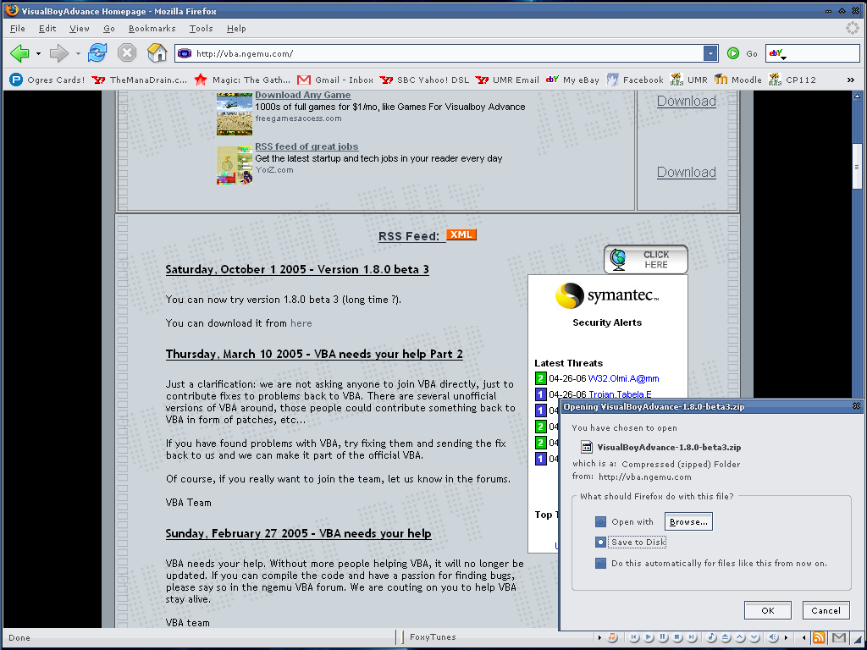

Controls for Ultimate Texas Hold ‘em:
As mentioned above, Ultimate Texas Hold’em was designed for the Gameboy Advance. Therefore the controls for the Gameboy Advance that are used are the D-Pad to move through different choices, set password, etc, as well as the select buttons A, B, and Start. When running this program on a computer it is through the use of a program called Visualboy Advance, an emulator for Gameboy Advance games. In this program it is simple to reconfigure the controls as seen in the picture below by going under Options -> Joypad -> Configure -> 1.



Next, you will be presented with a screen like such where you will be able to set whatever controls you wish.
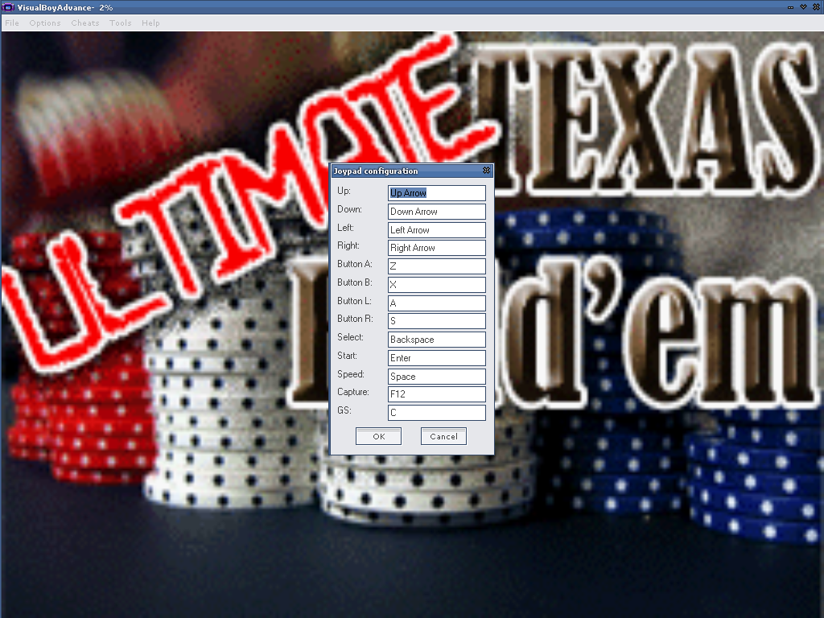

The default controls are:
Up: Up Arrow
Down: Down Arrow
Left: Left Arrow
Right: Right Arrow
Button A: Z
Button B: X
Select: Backspace
Start: Enter

Gameplay for Ultimate Texas Hold’em:
To play the game on the Gameboy Advance you simply turn on the unit and follow the on screen instructions, which are identical to the instructions for the version that runs on the computer. On the other hand, if running on the computer you must first have Visualboy Advance which can be found by typing in “Visualboy Advance” in a Google search engine as seen below, or by going to the website http://vba.ngemu.com/ and going to the downloads section. After selecting a mirror site to download from please save the .zip file to a suitable location. After the file is saved to your hard drive open up the .zip file and open up the file named “VisualBoyAdvance.exe”. Note: It is easier if you extract VisualBoyAdvance.exe to your hard drive before opening. After opening VisualBoyAdvance.exe you need to open the correct file for Ultimate Texas Hold’em. You do this by going under File -> Open and navigating until you find the .gba file. After the .gba file is opened the program will begin to run as if you were playing it on the Gameboy Advance.

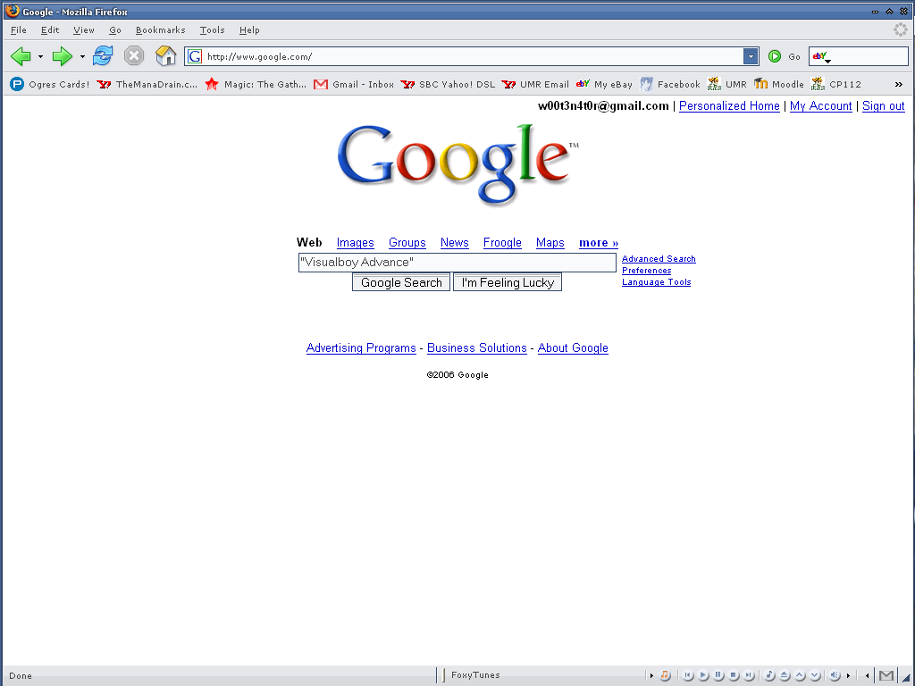
Find Visualboy Advance from Google
Once located save the .zip file to your Hard Drive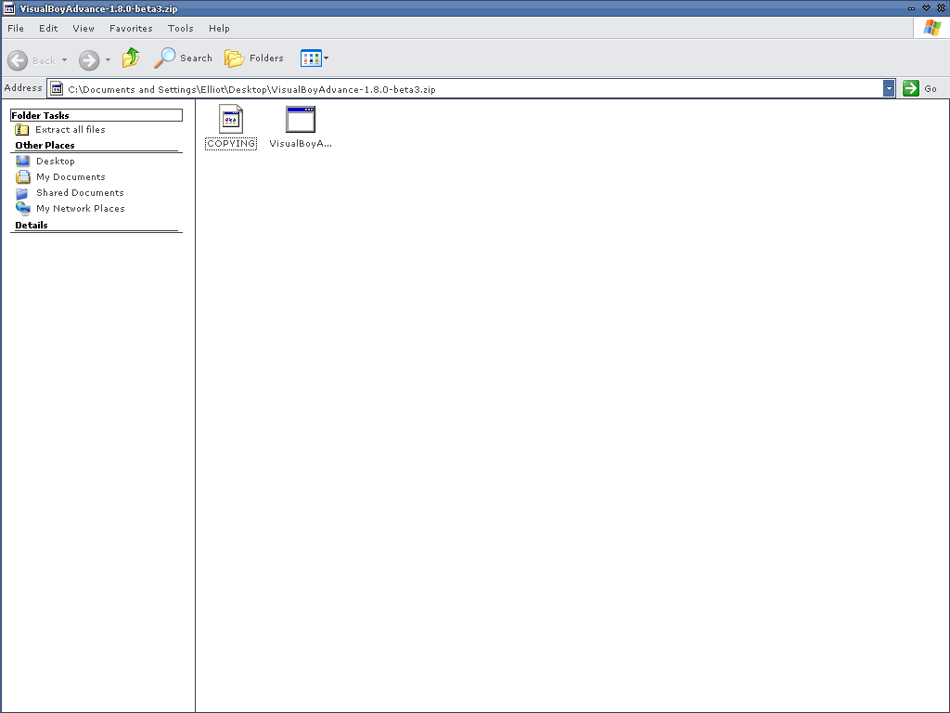
Open up the .zip file and open up the .exe file named VisualBoyAdvance.exe
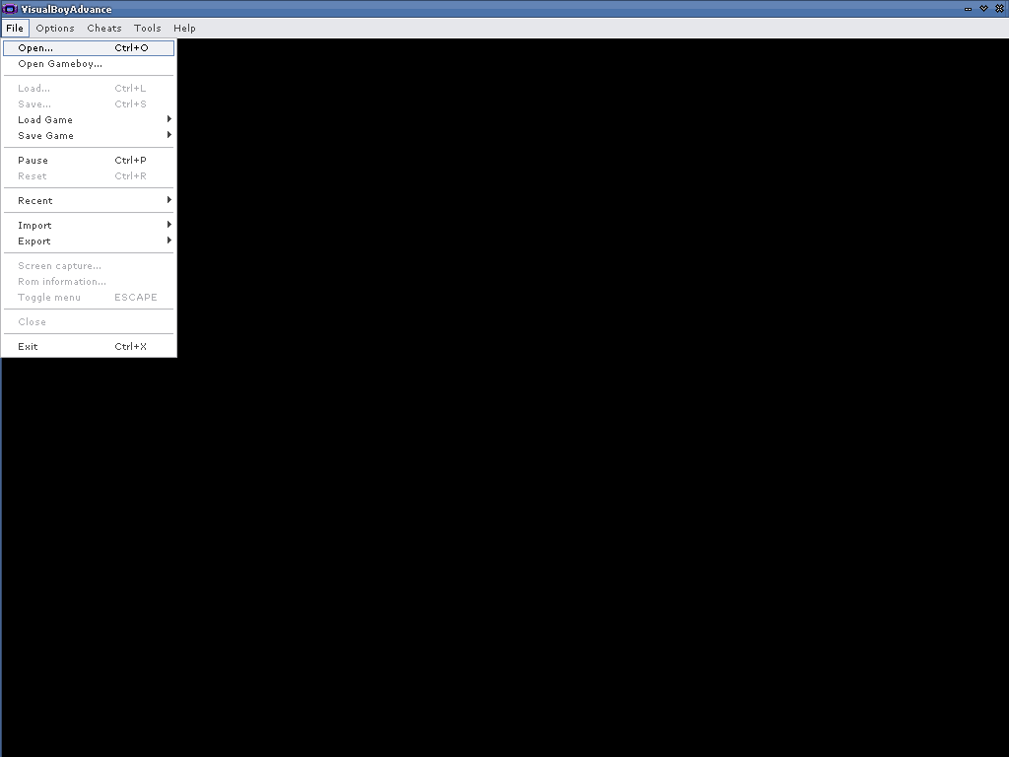
After opening VisualBoyAdvance.exe you need to open the correct file for Ultimate Texas Hold’em
Once the program is opened if will go to this opening title screen
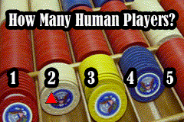
After pressing Start, it’ll ask how many human players will be playing
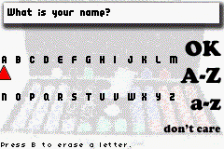
Then you will be presented with a screen that will prompt you to enter your name
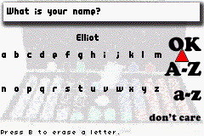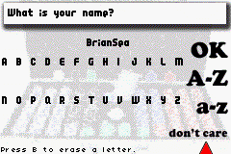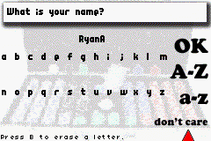
Here you have many options (You can enter your real name or if you don’t care press don’t care and you’ll be surprised what you get)
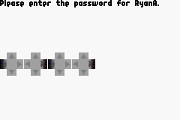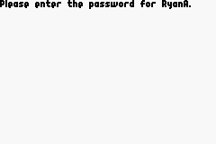
After selecting your name you will be prompted to put in your password and then asked to please enter your password. Note: This password is so when you are playing a game with multiple human players the others will not be able to see your hand. You will also be prompted for this password before every time that you can view your cards. If the password is entered incorrectly you will not be able to see the cards.
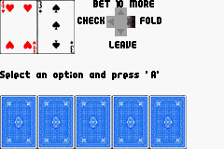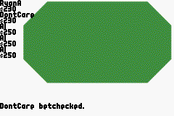
After entering the correct password you will get to see your hand along with the possible options you have which are Bet, Check, Leave, or Fold and will see this screen simulating the poker table
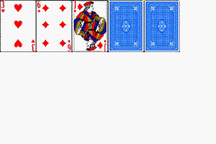
Then once all the players have checked/matched the appropriate bet there is an animation of the “Flop”, and after you will once again be prompted for your password
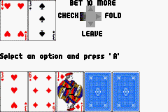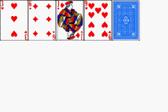
You will once again have the same choices as before, and next comes the “Turn” and be prompted for your password
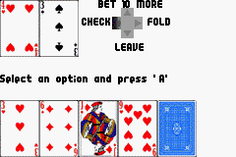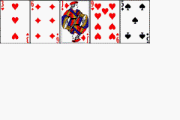
As before you will have choices once again, and next comes the “River” along with a prompt for your password
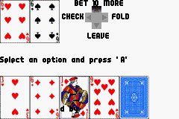
Well hopefully with a little luck and a lot of skill you can be like DontCare and snag a few wins yourself!
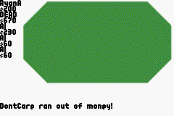
However, it can’t always end up that good and sometimes you must leave. After leaving it will once again return you to the title screen

The Rules of Texas Hold ‘em:
To begin, the user must first learn the rules of Texas Hold’em as well as the rules of poker in general. In Texas Hold’em each player is given a certain amount of money in which they usually “buy-in”. Next, there are a certain number of players at a given table.
Something that is unique to the game of Texas Hold’em compared to many other different forms of poker is that instead of an “ante” there are blinds, which are basically an amount of money that the player puts in the pot before seeing any cards. The blinds are determined by the position of the dealer chip that rotates around the table after each round. There are a total of two blinds, the big blind and the small blind. For each individual game there are different blinds that are dependant on the stakes at the table. For example, a small friendly game may have $.10 and $.20 blinds, where as at a casino or tournament the blinds can be upwards of $100 and $200. The player to the immediate left of the dealer is the small blind, and the player to his/her left is big blind.
The first step in the game is that each player that is playing at the table is given two cards face down, which are called the pocket cards. These two cards will be unique to each player, and will be hidden to all other players. After each player has been dealt these two cards a round of betting ensues in which the betting begins with the player to the left of big blind, in which they have the option of calling the big blind (for example if the big blind is $.20 they would “call” $.20), folding (meaning they do not wish to put in any money and wish to not play the rest of the round), or raising (an action where the big blind is met and the bet exceeds the big blind). This “preflop” stage continues until each player that is in the hand has put in the same amount of money into the pot.
The next step after the “preflop” stage is called the “flop”. The flop is a series of cards that are flipped face up in the middle of the table in which each player can use to make the best five card poker hand. It is also important to mention that a card is put face down in front of the dealer prior to flipping the next three cards. After the “flop” has been played, another round of betting continues. At this point the person immediately to the left of the dealer chip or “button” is the first to make a play. Now they may “check” (basically you wish to bet nothing), bet (bet a certain amount of money), or fold. Also, if a bet has been made already you can raise the bet as well. This sub round continues until every player that is still in has put an equal amount of money into the pot.
Next, after the “flop” is a stage called the “turn”. As done before, a card is “burned” (put face down in front of the dealer) prior to flipping the “turn card” face up. Now, each player that is still in the hand has a total of six cards in which to choose from to make the best five card poker hand. Another round of betting continues until each player has put an equal amount of money into the pot.
Finally, another card is “burned” and the “river” is flipped face up for all players to use. This is the final card that the remaining players will have to use to make their best five card poker hand. So in total each player will have a total of seven cards to choose from in order to make the best five card hand. Another round of betting ensues, and finally at the end of the hand each remaining player flips up their two pocket cards to reveal who has the best hand.

Hand Strength
(Card images from: http://www.texasholdem-poker.com/handrank.php)

High Card:
A high card is the highest card in your seven card hand. For example, if you had a hand consisting of Ace of spades, nine of clubs, two of diamonds, five of spades, and a seven of hearts your hand would be called a high card which is the ace of spades.

High Card - When you don't have any of the above, your highest card determines your hand. The example below would be "King High" or "High card King".
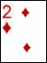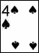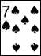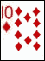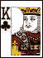

Pair:

The next best hand after a high card is called a pair. This hand is fairly self explanatory but consists of having two cards of the same value. For example, a pair consists of having two tens in your five card hand.

One Pair - Two cards of the same rank.
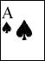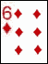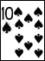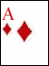
Two Pair:

The next best hand after a pair is called a two-pair. This hand is also fairly obvious, yet consists of two pairs. It is also important to note that if two players both have two pairs the player with the highest pair wins the hand. For example if one player has a pair of aces and a pair of twos, he would beat the other player who has a pair of kings and a pair of queens because the pair of aces is the best pair on the table.

Two Pair - Two cards of the same rank and another two cards of the same rank. The example below would be called "Jacks and Twos".
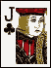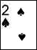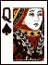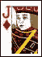

Three of a Kind:

Next, the next best hand after a two pair is called a three-of-a-kind. A three of a kind consists of having three cards of the same value. For example, you would have a three of a kind if you were holding three nines in your hand.
Three-of-a-Kind (Trips, Set) - Three cards of the same rank.
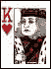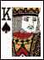

Straight:

The next best hand after a three of a kind is called a straight. A straight is where you have a run of five cards. For example, if you had an ace, king, queen, jack, and a ten you would have a straight ace high. It is important to note that aces can be either high or low. For example, if you had ace, two, three, four, five you would also have a straight because the ace acts as a one as well.

Straight (Run) - Five cards of sequential rank. Note that in hold 'em, Aces can be high or low.
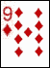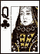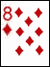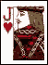
An example of a straight where the Ace is low:
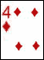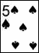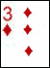

Flush:

Next, after a straight you have what is called a flush. If you have a flush it means that your five cards are entirely of the same suit (Hearts, Clubs, Diamonds, or Spades). If two players both have a flush the player with the highest kicker (highest value card) wins the pot.

Flush - Five cards of the same suit.
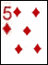

Full House:

The next best hand after a flush is called a full house. This is simply having both a three of a kind as well as a pair in your five card hand.

Full House (Full Boat, Boat) - Three-of-a-kind and a pair. The example below would be called "Queens over Aces" or "Queens full of Aces".
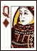
Four of a Kind:

Next, after a full house is a four of a kind, which obviously means having all four of a certain card. For example, having four sevens would mean that you have a four of a kind.

Four-of-a-Kind (Quads) - Four cards of the same rank.
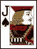
Straight Flush:
A straight flush is where you have a straight as well as a flush.

Straight Flush - A straight of entirely one suit.
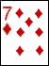
Royal Flush:
The best hand you could possibly have is called a Royal Flush which is nothing, but having a straight flush which is Ace through ten of the same suit.

Royal Flush - An Ace-High straight of one suit.

Known Issues:

- The first hand whenever you start a game is always a 4 and a 3
- Whenever you leave despite how much money you have it always says that you are out of money
- Text floats around the screen a little bit if the name is long
- If there is a split pot situation it declares only one winner, but it does separate the pot appropriately
- If you are not using version 1.8.0-beta3 of Visual Boy Advance and you attempt to run the program with sound Visual Boy Advance will crash.

Well we hope that this document has been very informative and helpful. Remember Good Luck!

